 | 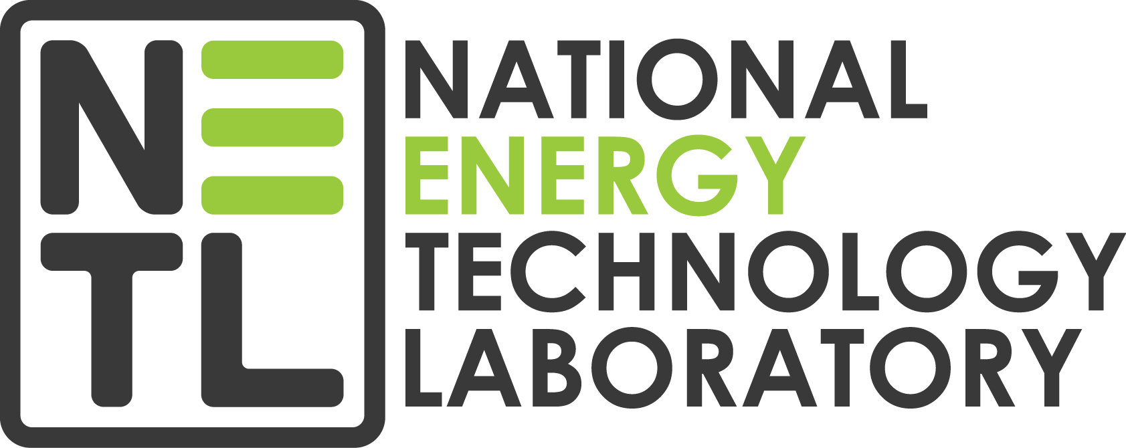
 | Document Management Market Analysis Questionnaire
[Pick the date] | January 15, 2020

DISCLAIMER

This document was prepared as an account of work sponsored by
an agency of the United States Government. Neither the United States
Government nor any agency thereof, nor any of their employees, makes
any warranty, express or implied, or assumes any legal liability or
responsibility for the accuracy, completeness, or usefulness of any
information, apparatus, product, or process disclosed, or represents that its
use would not infringe privately owned rights. Reference herein to any
specific commercial product, process, or service by trade name,
trademark, manufacturer, or otherwise does not necessarily constitute or
imply its endorsement, recommendation, or favoring by the United States
Government or any agency thereof. The views and opinions of authors
expressed herein do not necessarily state or reflect those of the United
States Government or any agency thereof.

Vendor Questionnaire

Summary
The National Energy Technology Laboratory (NETL) is performing a market analysis of Off-the-shelf products focused on document management and business process workflow to determine applicability the document management needs of NETL. The result of this effort will inform our future strategic plans and does not imply that NETL will be imminently procuring a solution.

In an effort to help NETL, an integrated product team (IPT) was put together to help provide a list of potential solutions that could meet the needs of NETL. Team KeyLogic under the Mission Execution and Strategic Analysis (MESA) contract was assigned to help with the analysis of collecting the requirements across NETL and performing a market analysis of solutions to meet the needs of NETL.

This questionnaire will allow the team to present the information to the IPT to inform NETL’s future.

Questions

Licensing
Please provide as much detail and cost regarding the licensing model of an on-premise implementation of your product. To provide equal basis for analysis across all solutions, please use the following information as a basis for the license determination cost. Please note that the following information is only meant to allow for a comparative TCO analysis.

- Users: 500 users
- Admin Users (users with highest privileges meant to configure the solution): 10 users
- Number of overall Packages: 1,000,000 documents
- Number of Packages per year: 1,000 documents
- Total File Size of all Packages: 15 Terra Bytes

On Premise Solution (Option 1)

Hardware
Please provide the hardware specifications required to implement the solution on-premise. Assume that NETL will procure all hardware required or will utilize existing private cloud. NETL uses VMware for virtualization of servers. To provide equal comparative analysis across solutions, please use the information above to provide the optimal hardware needed.

Installation
Please provide a representative installation plan on the installation of the solution on the NETL private cloud. Please assume that NETL IT personnel will do the actual installation on the servers. The installation plan will be used to estimate a time and cost for NETL to perform the installation.

Scheduled Solution Upgrades
Please provide a plan, including any costs, related to the continued update release of software updates of the solution to NETL. If the cost is part of another category in this document such as license cost or maintenance cost, then please do not include that cost here.

FEDRAMP Moderate Cloud Solution (Option 2)
Please provide any additional cost (if any) for storage, data transfer, or any additional cost that is not mentioned in the licensing model. Please use the values provided in the licensing to get to the additional cost model.

Training
Please provide a training strategy and cost for the training for the solution. Please provide a separate cost and time for training the Admin users to be able to configure and use the advanced configuration of the solution. Please provide any cost and time of training the IT personnel for installation and maintenance of the server (if required). Also, please provide any cost and time (if any) for additional training to general users. If the documentation and videos are generally available on your site and has no additional cost, then please indicate that.

Configuration and Setup
NETL has several unique configurations for each department within NETL. This will provide some challenges while configuring your software to meet the distinct business requirement for each department. To provide equal analysis of all solutions, please provide a plan to work with 10 unique departments to configure the solution to meet their specific needs. If your organization works with, or requires; implementation partners, please provide a list of those partners so that NETL can contact them to get an estimate of work. If your organization plans to do the configuration or subcontract the work, then please indicate your plan to do the work and any hourly rates or fixed costs to implement the configuration.

Authority to Operate
Please indicate if the solution, or other products from your company, has been implemented in the Department of Energy (DOE) or any of the National Labs under the DOE. If so, please indicate what product and what entity within the DOE you have your product installed. Also, if possible, please provide contact information for that entity.

Maintenance and Support
Please provide your yearly maintenance and support cost (if any) to maintain the software. Please break out the cost into line items describing what the cost represents. You can utilize the numbers listed above for any analysis that would impact the cost.

Please choose either option 1 or option 2 for the solution but not both.

